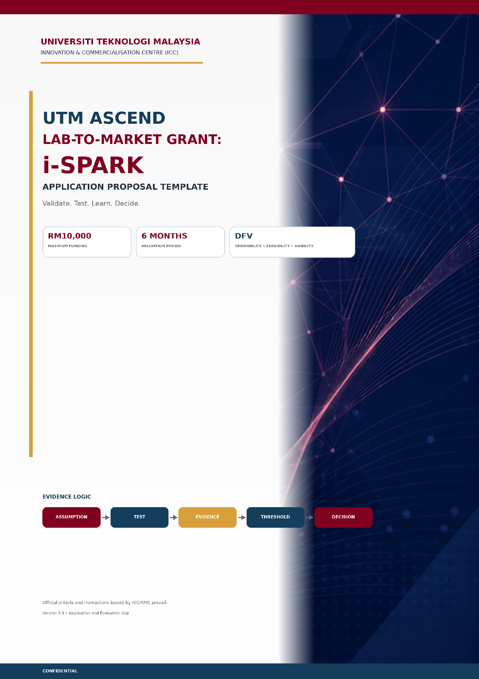
A | INSTRUCTIONS TO APPLICANTS  Read before completing the proposal

Purpose of this template
This proposal is designed to capture the innovation, customer problem, critical assumptions, validation tests, evidence thresholds, six-month plan and intended commercialisation decision. It is not a conventional research proposal.

Submission rules
- Complete all sections. Where a section is genuinely not relevant, state “NR – Not Relevant” and provide a brief reason.
- Do not delete headings, prompts or tables. Additional rows may be added where required.
- Use evidence and specific statements. Avoid unsupported claims such as “high demand”, “no competitors” or “large market”.
- Attach the required BMC, VPC, initial Business Testing Plan and evidence of training completion.
- Submit the final proposal through INNOCOMM. Key system fields should contain a concise summary and a reference to the relevant section/page of this proposal.
- Convert the completed document to PDF before submission, unless otherwise instructed by ICC/RMC.
Core evidence logic
ASSUMPTION | TEST | EVIDENCE | THRESHOLD | DECISION
Every major activity and budget item should contribute to this evidence chain.
Pre-submission checklist
✓ | CHECKLIST ITEM
☐ | Project Leader and at least one main team member completed BMC, VPC and Business Testing training.
☐ | The team involves at least two different faculties/schools/research entities.
☐ | At least one team member has relevant market, industry, business, commercialisation or target-application knowledge.
☐ | The proposal identifies critical assumptions across Desirability, Feasibility and Viability.
☐ | The six-month validation plan, testing methods, milestones and budget are complete.
☐ | BMC, VPC, initial Business Testing Plan and training evidence are attached.
☐ | Any initial customer/industry/stakeholder access evidence is attached, where available.

1 | PROJECT IDENTIFICATION  Administrative and project-level information

1.1 PROJECT DETAILS
Project Title | [Enter concise project title]
Project Leader | [Name, staff ID, designation]
Faculty / School / Research Entity | [Enter primary entity]
Email / Contact Number | [Enter contact details]
UTM / Industry / National Priority Area | [Select and state at least one relevant area]
Current Technology Readiness Level (TRL) | [Enter TRL and brief basis/evidence]
Funding Requested | RM [amount, maximum RM10,000]
Project Duration | 6 months
Proposed Start and End Dates | [Enter dates as announced by ICC/RMC]
Existing IP / Disclosure Reference | [Enter details or NR]
Proposed SLPP SRA | [Name/programme, if identified]

1.2 Proposed commercialisation outcome at the end of validation Select the most likely current pathway; this may change based on evidence.
☐ Proceed to development | ☐ Pivot application/market | ☐ Collaborate with industry
☐ License / technology transfer | ☐ Seek further funding | ☐ Pause / stop / discontinue
☐ Other: ___________

2 | EXECUTIVE VALIDATION SUMMARY  Maximum 300 words

Write a validation summary, not a technical abstract
Explain the innovation, target customer/industry, problem, current uncertainty, what will be tested within six months, the evidence to be generated and the decision expected at project completion.

[Maximum 300 words]

3 | TEAM ELIGIBILITY, CAPABILITY AND ROLES  Demonstrate cross-faculty and market/industry capability

3.1 Eligibility confirmation
✓ | ELIGIBILITY STATEMENT | EVIDENCE / REFERENCE
☐ | Project Leader is UTM academic staff (permanent or contract). | [Enter]
☐ | If the Project Leader is a non-citizen contract staff member, at least one co-researcher is a permanent Malaysian citizen staff member. | [Enter]
☐ | The team involves at least two different faculties, schools or research entities. | [Enter]
☐ | At least one team member has relevant market, industry, business, commercialisation or target-application experience. | [Enter]
☐ | The Project Leader is submitting only one active i-SPARK application at this time. | [Enter]
☐ | Project Leader and at least one main team member completed all required training. | [Enter]
3.2 Team composition and responsibilities
Name | Faculty / Entity | Role | Relevant Expertise | Expected Contribution
[Enter] | [Enter] | [Enter] | [Enter] | [Enter]
[Enter] | [Enter] | [Enter] | [Enter] | [Enter]
[Enter] | [Enter] | [Enter] | [Enter] | [Enter]
[Enter] | [Enter] | [Enter] | [Enter] | [Enter]
[Enter] | [Enter] | [Enter] | [Enter] | [Enter]
3.3 Role of SLPP SRA, if applicable Focus on evidence collection, customer discovery, market analysis, IP/patent mapping, data management and documentation.
[Enter response here]

4 | INNOVATION AND CURRENT READINESS  What exists, what is proven and what remains uncertain

4.1 Innovation description Describe the core function, novelty and intended use. Avoid a lengthy literature review.
[Enter response here]

4.2 Current technical readiness and evidence State current TRL, completed work, test results and constraints.
[Enter response here]

4.3 Current market/commercial readiness State what is known and not yet known about customer need, adoption, pricing, delivery and route to market.
[Enter response here]

4.4 Intellectual property status State existing IP, ownership, disclosure/registration status, foreground IP potential or NR.
[Enter response here]

5 | CUSTOMER PROBLEM AND MARKET CONTEXT  Define the customer, problem and existing alternatives

5.1 Primary customer / stakeholder segment Distinguish user, buyer, decision-maker and beneficiary where they are different.
Role | Who are they?
Primary User | [Enter]
Buyer / Payer | [Enter]
Decision-maker | [Enter]
Other Stakeholder | [Enter]

5.2 Customer problem statement Use: “[Target customer] experiences [specific problem] when [context], resulting in [measurable consequence].”
[Enter response here]

5.3 Existing alternatives and current behaviour How is the problem solved today? What happens if the customer does nothing?
[Enter response here]

6 | VPC and BMC

6.1 Value Proposition Canvas (VPC) summary

Please attach your VPC

6.2 Business Model Canvas (BMC) summary State the current logic only; it is expected to change after testing.

Please attach your BMC

7 | ASSUMPTION IDENTIFICATION

Prioritise the riskiest assumptions first
A critical assumption is an uncertain belief that could materially change the project or commercialisation decision if proven wrong. Include assumptions across Desirability, Feasibility and Viability.

ID | Critical Assumption | Dimension | Existing Evidence | Confidence | Consequence if Wrong
A1 | [Enter] | [Enter] | [Enter] | [Enter] | [Enter]
A2 | [Enter] | [Enter] | [Enter] | [Enter] | [Enter]
A3 | [Enter] | [Enter] | [Enter] | [Enter] | [Enter]
7.1 Top three assumptions to test first Explain why these assumptions have the highest uncertainty and consequence.
[Enter response here]

8 | VALIDATION OBJECTIVES AND QUESTIONS  Translate assumptions into answerable validation questions

No. | Dimension | Validation Objective | Key Question(s)
1 | [Enter] | [Enter] | [Enter]
2 | [Enter] | [Enter] | [Enter]
3 | [Enter] | [Enter] | [Enter]
4 | [Enter] | [Enter] | [Enter]
5 | [Enter] | [Enter] | [Enter]
6 | [Enter] | [Enter] | [Enter]

9 | BUSINESS TESTING AND EVIDENCE PLAN  Assumption → Test → Evidence → Threshold → Decision

Panel focus
Tests must be proportionate to the uncertainty. Each test should identify the target participant/data source, evidence to be collected, pre-defined success threshold and decision if the threshold is met or not met.

9.1 Test design
Test ID | Critical Assumption | DFV | Test / Method | Target Participant / Data Source
T1 | [Enter] | [Enter] | [Enter] | [Enter]
T2 | [Enter] | [Enter] | [Enter] | [Enter]
T3 | [Enter] | [Enter] | [Enter] | [Enter]
9.2 Evidence, threshold and decision
Test ID | Evidence to Collect | Success Threshold | Decision if Met / Not Met
T1 | [Enter] | [Enter] | [Enter]
T2 | [Enter] | [Enter] | [Enter]
T3 | [Enter] | [Enter] | [Enter]
9.3 Testing sequence and learning logic Explain dependencies between tests, what will be learned first and how earlier evidence will change later tests.
[Enter response here]

10 | BUSINESS PROTOTYPE / MARKET-TEST ARTEFACT  Build only what is needed to generate evidence

The artefact is a test instrument
A complete technology prototype is not required at application stage. The selected artefact must be directly linked to the assumption being tested and the evidence to be collected.

Proposed Artefact | Assumption Tested | Who Will Interact With It | Evidence Generated
[Enter] | [Enter] | [Enter] | [Enter]
[Enter] | [Enter] | [Enter] | [Enter]
[Enter] | [Enter] | [Enter] | [Enter]
10.1 Why this is the simplest appropriate artefact Examples may include mock-up, storyboard, landing page, clickable prototype, service simulation, pricing test, pre-order form, concierge test or demonstration of concept.
[Enter response here]

11 | CUSTOMER, INDUSTRY AND STAKEHOLDER ACCESS  Show how evidence can realistically be obtained

Target Organisation / Group | Target Role | Access Method / Contact | Expected Number | Timing | Responsible Person
[Enter] | [Enter] | [Enter] | [Enter] | [Enter] | [Enter]
[Enter] | [Enter] | [Enter] | [Enter] | [Enter] | [Enter]
[Enter] | [Enter] | [Enter] | [Enter] | [Enter] | [Enter]
11.1 Access risks and mitigation Include confidentiality, IP disclosure, participant recruitment and data/privacy considerations.
[Enter response here]

12 | SIX-MONTH MILESTONE AND VALIDATION PLAN  Milestones should reflect evidence progression, not only activities

Month | Main Activity | Assumption / Test | Evidence / Output | Decision Point | Lead | Status
1 | [Enter] | [Enter] | [Enter] | [Enter] | [Enter] | [Enter]
2 | [Enter] | [Enter] | [Enter] | [Enter] | [Enter] | [Enter]
3 | [Enter] | [Enter] | [Enter] | [Enter] | [Enter] | [Enter]
4 | [Enter] | [Enter] | [Enter] | [Enter] | [Enter] | [Enter]
5 | [Enter] | [Enter] | [Enter] | [Enter] | [Enter] | [Enter]
6 | [Enter] | [Enter] | [Enter] | [Enter] | [Enter] | [Enter]
12.1 Monitoring readiness Identify the evidence to be presented at the minimum two monitoring sessions and the final Validation Symposium.
Review Point | Planned Timing | Evidence / Documents | Decision Required
Monitoring 1 | [Enter] | [Enter] | [Enter]
Monitoring 2 | [Enter] | [Enter] | [Enter]
Final Symposium | [Enter] | [Enter] | [Enter]

13 | BUDGET AND JUSTIFICATION  Every item must support a validation activity, evidence requirement or milestone

Budget principles
Maximum request: RM10,000. Expenditure must relate directly to market validation. Technology development without a clear validation link is not allowed. Include RM500 for participation in the i-SPARK Validation Symposium.

V-Code | Budget Item | Validation Activity / Test | Amount (RM) | Evidence / Output | Justification
V11000 | SLPP SRA allowance | [Enter] | [Enter] | [Enter] | [Enter]
V21000 | Domestic travel / transport | [Enter] | [Enter] | [Enter] | [Enter]
V24000 | Market research tools / rentals | [Enter] | [Enter] | [Enter] | [Enter]
V29000 | Prototype / testing / specialised service | [Enter] | [Enter] | [Enter] | [Enter]
V29000 | i-SPARK Validation Symposium | [Enter] | 500.00 | [Enter] | [Enter]
V35000 | Small equipment / materials | [Enter] | [Enter] | [Enter] | [Enter]
 | [Enter] | [Enter] | [Enter] | [Enter] | [Enter]
 | [Enter] | [Enter] | [Enter] | [Enter] | [Enter]
 | [Enter] | [Enter] | [Enter] | [Enter] | [Enter]
 | [Enter] | [Enter] | [Enter] | [Enter] | [Enter]
 | TOTAL REQUEST |  | [Enter]
13.1 Budget narrative Explain overall value for money, why the selected methods are proportionate and how the budget avoids overbuilding the technology.
[Enter response here]

14 | EXPECTED OUTPUTS AND EVIDENCE COMMITMENT  State what will be delivered and how it will demonstrate learning

✓ | MANDATORY OUTPUT | PLANNED EVIDENCE / DELIVERABLE | DUE / RESPONSIBLE
☐ | Market Validation Report | [Enter] | [Enter]
☐ | Industry Demand Validation | [Enter] | [Enter]
☐ | Evidence-based Desirability, Feasibility and Viability assessment | [Enter] | [Enter]
☐ | Updated Business Model Canvas and Value Proposition Canvas | [Enter] | [Enter]
☐ | Business Testing Record (assumption, test, evidence, threshold and decision) | [Enter] | [Enter]
☐ | At least one validated business prototype or market-test artefact, where appropriate | [Enter] | [Enter]
☐ | Sufficient evidence of testing and customer/industry engagement | [Enter] | [Enter]
☐ | Recommended Commercialisation Pathway | [Enter] | [Enter]
☐ | One IP or recommendation for IP development/protection, where relevant | [Enter] | [Enter]
☐ | Presentation at i-SPARK Validation Symposium | [Enter] | [Enter]

15 | COMMERCIALISATION DECISION FRAMEWORK  Define how evidence will lead to action

15.1 Current recommended pathway and rationale This is the pre-project view and may change after validation.
[Enter response here]

16 | RISKS, ETHICS, CONFIDENTIALITY AND IP PROTECTION  Protect evidence quality, participants and commercial potential

Risk | Likelihood | Impact | Mitigation / Control | Owner
Customer access | [Enter] | [Enter] | [Enter] | [Enter]
Technical / operational | [Enter] | [Enter] | [Enter] | [Enter]
Team capacity | [Enter] | [Enter] | [Enter] | [Enter]
Procurement / timeline | [Enter] | [Enter] | [Enter] | [Enter]
Data / ethics / privacy | [Enter] | [Enter] | [Enter] | [Enter]
Confidentiality / IP disclosure | [Enter] | [Enter] | [Enter] | [Enter]
Other | [Enter] | [Enter] | [Enter] | [Enter]
16.1 IP disclosure protocol during customer discovery Explain what may be shared, what must remain confidential and when NDA/other controls are required.
[Enter response here]

17 | ATTACHMENT CHECKLIST  Attach current versions produced during or after the required training

✓ | ATTACHMENT | FILE NAME / REFERENCE
☐ | Evidence of completion of BMC, VPC and Business Testing training – Project Leader | [Enter]
☐ | Evidence of completion of BMC, VPC and Business Testing training – at least one main team member | [Enter]
☐ | Business Model Canvas (BMC) | [Enter]
☐ | Value Proposition Canvas (VPC) | [Enter]
☐ | Initial Business Testing Plan | [Enter]
☐ | Team profiles / short CVs | [Enter]
☐ | Six-month milestone plan (if separately provided) | [Enter]
☐ | Detailed budget / quotation / cost basis, where relevant | [Enter]
☐ | Existing IP information / disclosure / ownership evidence, where relevant | [Enter]
☐ | Initial customer / industry / stakeholder access evidence, where available | [Enter]
☐ | Other supporting evidence: ______________________________ | [Enter]

18 | PROJECT LEADER DECLARATION  Confirm accuracy, eligibility and commitment

Declaration
I confirm that the information provided in this proposal is accurate to the best of my knowledge; the team meets the applicable eligibility requirements; the proposed expenditure is directly linked to validation activities; required training and attachments have been completed; and the team agrees to comply with ICC/RMC monitoring, financial and reporting requirements.

Project Leader Name | [Enter]
Staff ID | [Enter]
Signature
Date | [Enter]
Official Contact | [Enter]
END OF i-SPARK APPLICATION PROPOSAL TEMPLATE
Official criteria and instructions issued by ICC/RMC prevail in the event of any inconsistency.

