Detailed Project Proposal ICCubeX+

Universiti Teknologi Malaysia



UTM Innovation and Commercialisation Centre, Industry Centre, UTM Technovation Park, 81300 UTM Johor Bahru, Johor
Project Proposal ICCubeX+
1. General Information
Name of Principal Investigator
Team members and their role in the project (University and Industry collaborator)
Industry Collaborator (Company’s name)
Title of Proposed Project
Research Area | - Frontier Materials Research Alliance  - Resource Sustainability Research Alliance  - Innovative Engineering Research Alliance  - Smart Digital Community Research Alliance  - Health & Wellness Research Alliance  Other, please specify:
Filed/Granted Intellectual Property
Duration of the project | 24 months
Total amount of the project | Universiti: RM  Industry Collaborator: RM  Total: RM
Duration of collaboration with the industry (before application)

2. Technology Information
2. a) Executive Summary of Technology
Please include the Technology overview & problem, value proposition & uniqueness, TRL level, market/application potential, competitive position, commercialisation pathway & next steps (200-250 words)

2. b) Type of IP
Type of IP:
File number:

3. TRL, CRL & Technology Plan
3. a) Explain the TRL & CRL for the project applied with a brief description of the product
Choose CURRENT TRL & CRL based on Appendix 1 & 2
A brief description of the proposed project/product (50-100 words)

3. b) Explain the TRL & CRL for the project applied with a brief description of the product
Choose TARGET TRL & CRL based on Appendix 1 & 2
A brief description of the output of the proposed project/product (50-100 words)

3. c) Technology Plan
Sustainable Technology Road map Being Proposed for the product

4. Commercialization Model
Choose one commercialisation model

- One-off licensing; or
- Commercialization/royalty programme

Please include a brief explanation of the selected commercialisation model (either one-off licensing or a commercialisation/royalty programme), covering the rationale for selection, implementation approach, roles of involved parties, and alignment with the technology’s readiness and market potential (200-250 words)

5. Market Study

Please include an indicative market estimation and a concise market entry strategy aligned with the target market, application context, and the technology’s readiness for commercialisation. (100-150 words)

5. a) Market Analysis
How big the market (Unit, Sales, Revenue)
Market trends, impact the community /industry

5. b) Market Competition
Market approach
Competitive

6. Business Plan

6. a) Return of investment (ROI)
Please include an indicative ROI expectation and an estimated break-even period (calculation in table), supported by reasonable assumptions aligned with the proposed commercialization approach.

6. b) Research Funding Requirements and Scale-up Financing Needs
Please state the funding requirements and financing needs for scale-up, aligned with the technology’s development stage and commercialisation objectives.
Universiti: RM (Maximum RM500,000 only)
Industry collaborator: RM (Compulsory minimum of 5% contribution)
Total: RM

7. Expected Output (Please refer fund criteria)
7. a) Technology Development & commercialization:

7. b) Prototype Development & Performance Monitoring:

7. c) Market Research & Market Validation:

7. d) Human Capital Development Outputs (Master's & PhD Students):

7. e) ICCubeX Entrepreneurship Development Program:

7. f) Start-up/ spin-off & Entrepreneurship Impact:

8. Economy and Societal Impact

Please include a concise explanation of the expected impact of the commercialisation on the university, in terms of research output, intellectual property, revenue potential, and strategic value.

9. Project Schedule
No. | Task | Name (PIC) | Start Date | End Date

10. Project Milestone
No. | Milestone | Date

11. Budget
V-Series | SODO Type | Description | Cost Year 1 | Cost Year 2 | Justification | Total Cost
V11000  Salary & Wage / Overtime  (Capping 0.00%) | B11000  Salary & Wages
 | Total Per Sodo
B12000
Fixed Allowances
 | Total Per Sodo
B13000
Statutory Contribution to Public Staff
 | Total Per Sodo
B14000
Overtime
 | Total Per Sodo
B15000
Other Financial Benefits Staff
 | Total Per Sodo
Total Per VSeries (V11000)
V21000  Travelling Expenses & Subsistence  (Capping 20.00%) | B21000  Travel & subsistence
 | Total Per Sodo
B22000
Transport of Goods
 | Total Per Sodo
Total Per VSeries (V21000)
V24000  Rentals  (Capping 0.00%) | B23000  Transportation & Utilities
 | Total Per Sodo
B24000
Rentals
 | Total Per Sodo
Total Per VSeries (V24000)
V26000  Research Materials & Supplies  (Capping 0.00%) | B26000  Raw Materials & Spare Parts
 | Total Per Sodo
B27000
Supplies & Consumable Goods
 | Total Per Sodo
Total Per VSeries (V26000)
V28000  Maintenance & Minor Repair Service  (Capping 0.00%) | B28000  Maintenance & Repairs
 | Total Per Sodo
Total Per VSeries (V28000)
V29000  Professional Services  (Capping 0.00%) | B29000  Professional Services & Hospitality
 | Total Per Sodo
Total Per VSeries (V29000)
V35000  Special Equipment & Accessories  (Capping 40.00%) | B34000  Vehicle
 | Total Per Sodo
B35000
Assets & Equipments
 | Total Per Sodo
B36000
Inventory & Furnitures
 | Total Per Sodo
Total Per VSeries (V35000)
V40000  Biasiswa, Dermasiswa dan Bantuan Pelajaran  (Capping 0.00%) | B41000  Biasiswa, Dermasiswa dan Bantuan Pelajaran
 | Total Per Sodo
Total Per VSeries (V40000)
V50000  Other Charges & Distribution  (Capping 0.00%) | B52000  Other Charges & Distribution
 | Total Per Sodo
Total Per VSeries (V50000)
Grand Total Per Year

12. Declaration
All information provided within these documents are true and correct when given. If any information is untrue, inaccurate or misleading, UTM has the right to not process the application, reject the application or to withdraw the offer without prior notice.
Project leader name:
Sign & Stamp:

Date:

Appendix 1

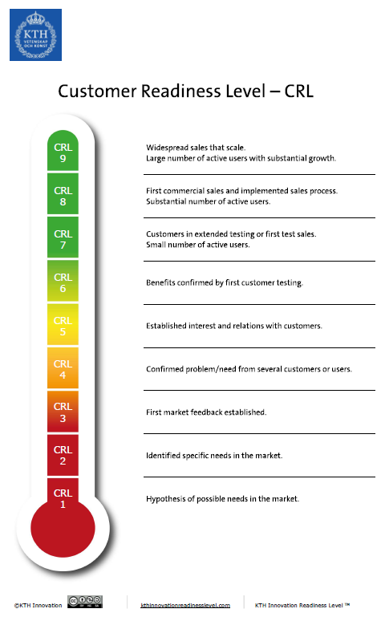
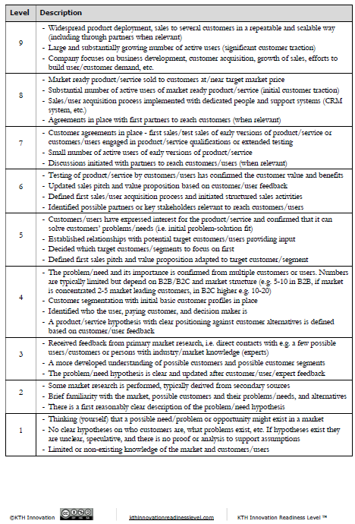

Appendix 2

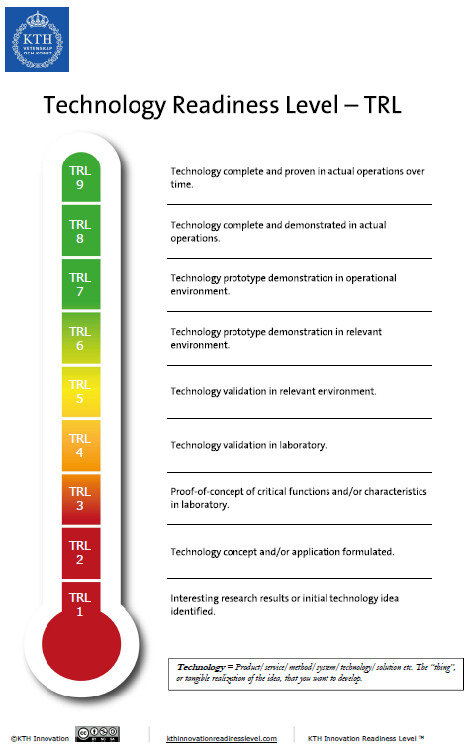

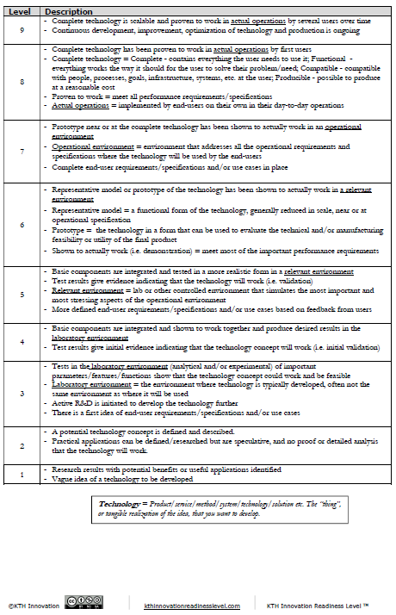

UTM Innovation and Commercialisation Centre, Industry Centre, UTM Technovation Park, 81300 UTM Johor Bahru, Johor

©2025 Universiti Teknologi Malaysia

