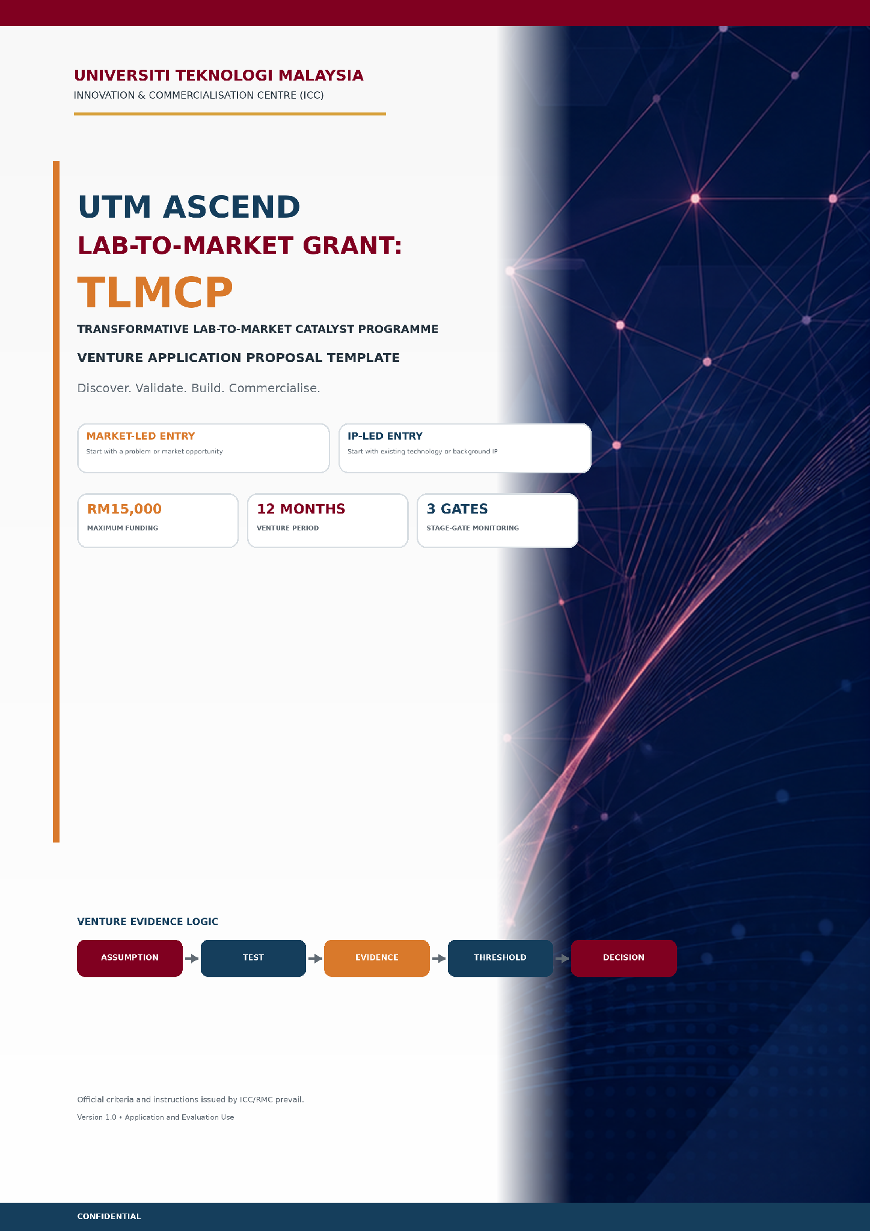
A | INSTRUCTIONS TO APPLICANTS | READ BEFORE PREPARING THE PROPOSAL

PURPOSE | This template guides applicants to present a venture proposal based on evidence, critical assumptions, testing, stage-gate decisions and a clear commercialisation pathway.

Submission rules
• Complete all common sections and select ONE entry mode: Market-Led Entry or IP-Led Entry.
• Complete Section 4A for Market-Led Entry or Section 4B for IP-Led Entry. Mark the non-applicable section as "NR - Not Relevant" and provide a brief reason.
• Do not delete headings, prompts or tables. Additional rows may be added when required.
• Use specific evidence. Avoid unsupported claims such as "high demand", "no competitors" or "large market".
• Attach evidence of completion of the mandatory BMC, VPC and Business Testing training, together with the initial BMC, VPC and Business Testing Plan.
• Submit through INNOCOMMS or the method specified by ICC/RMC. Convert the final document to PDF unless instructed otherwise.
Core venture evidence logic
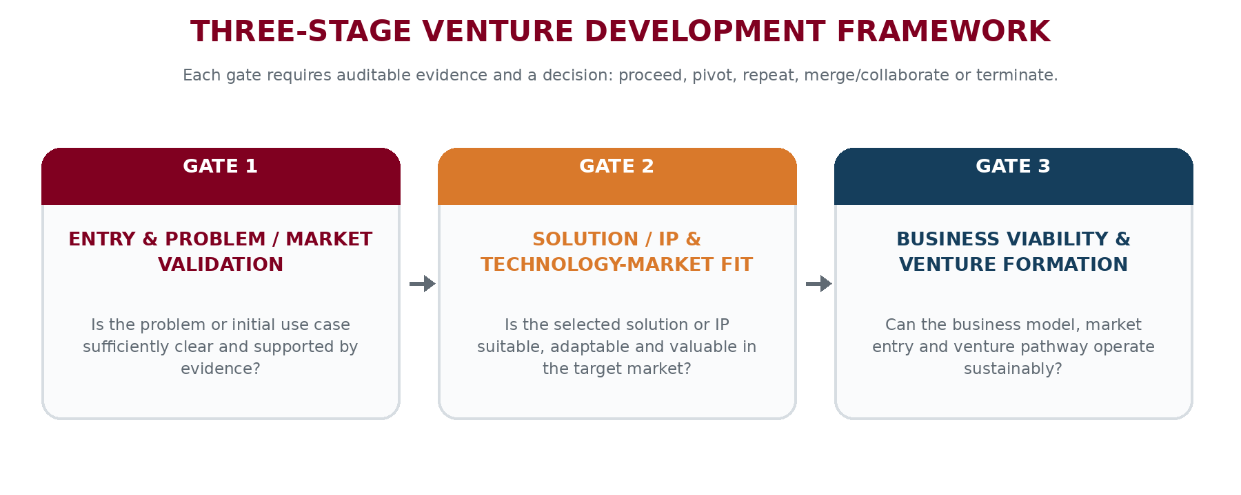
Figure 1. TLMCP three-stage venture development framework.
DECISION RULE | Every major activity and budget item should contribute to: Assumption -> Test -> Evidence -> Threshold -> Decision.

Pre-submission checklist
Selection | Requirement | Applicant confirmation / evidence
[ / ] | Venture Lead, team members and mentor meet the eligibility requirements. | 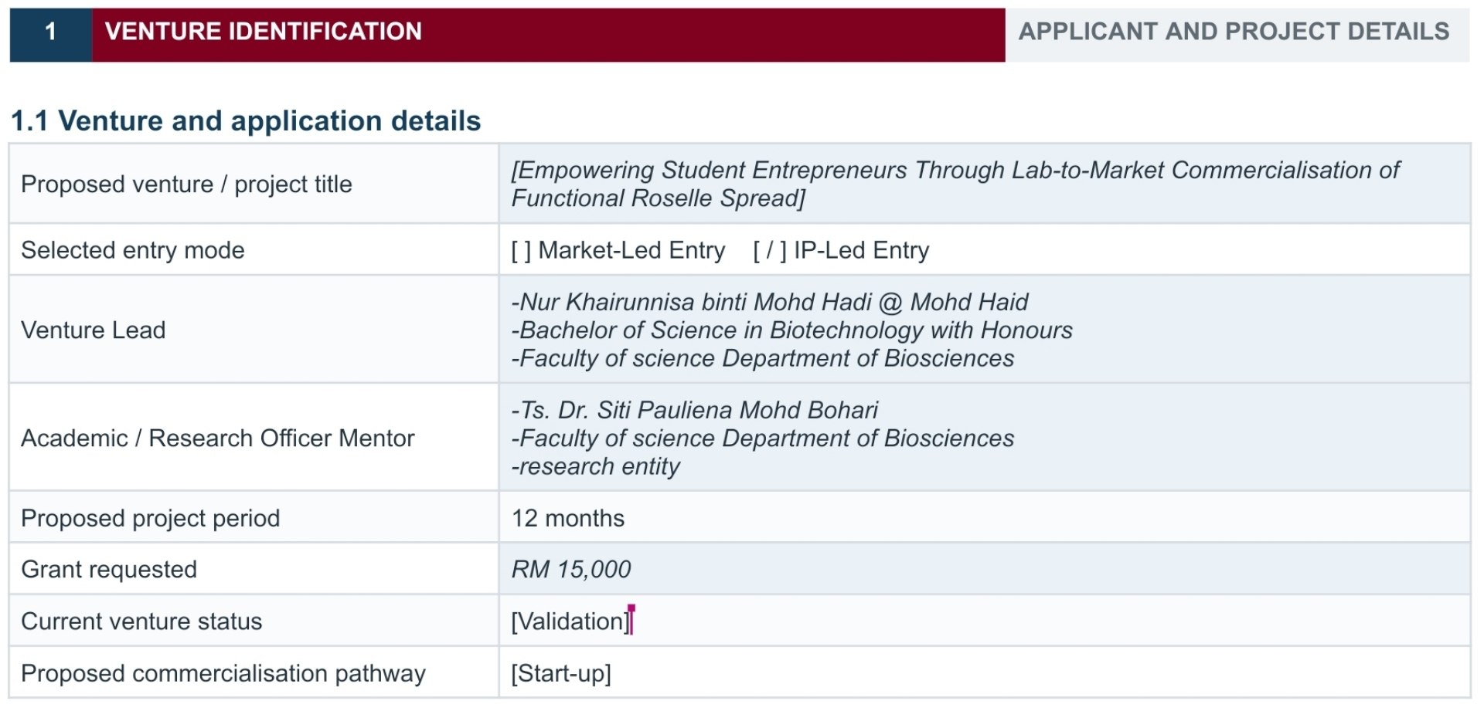
[ / ] | The team has selected one entry mode and completed the correct conditional section. | 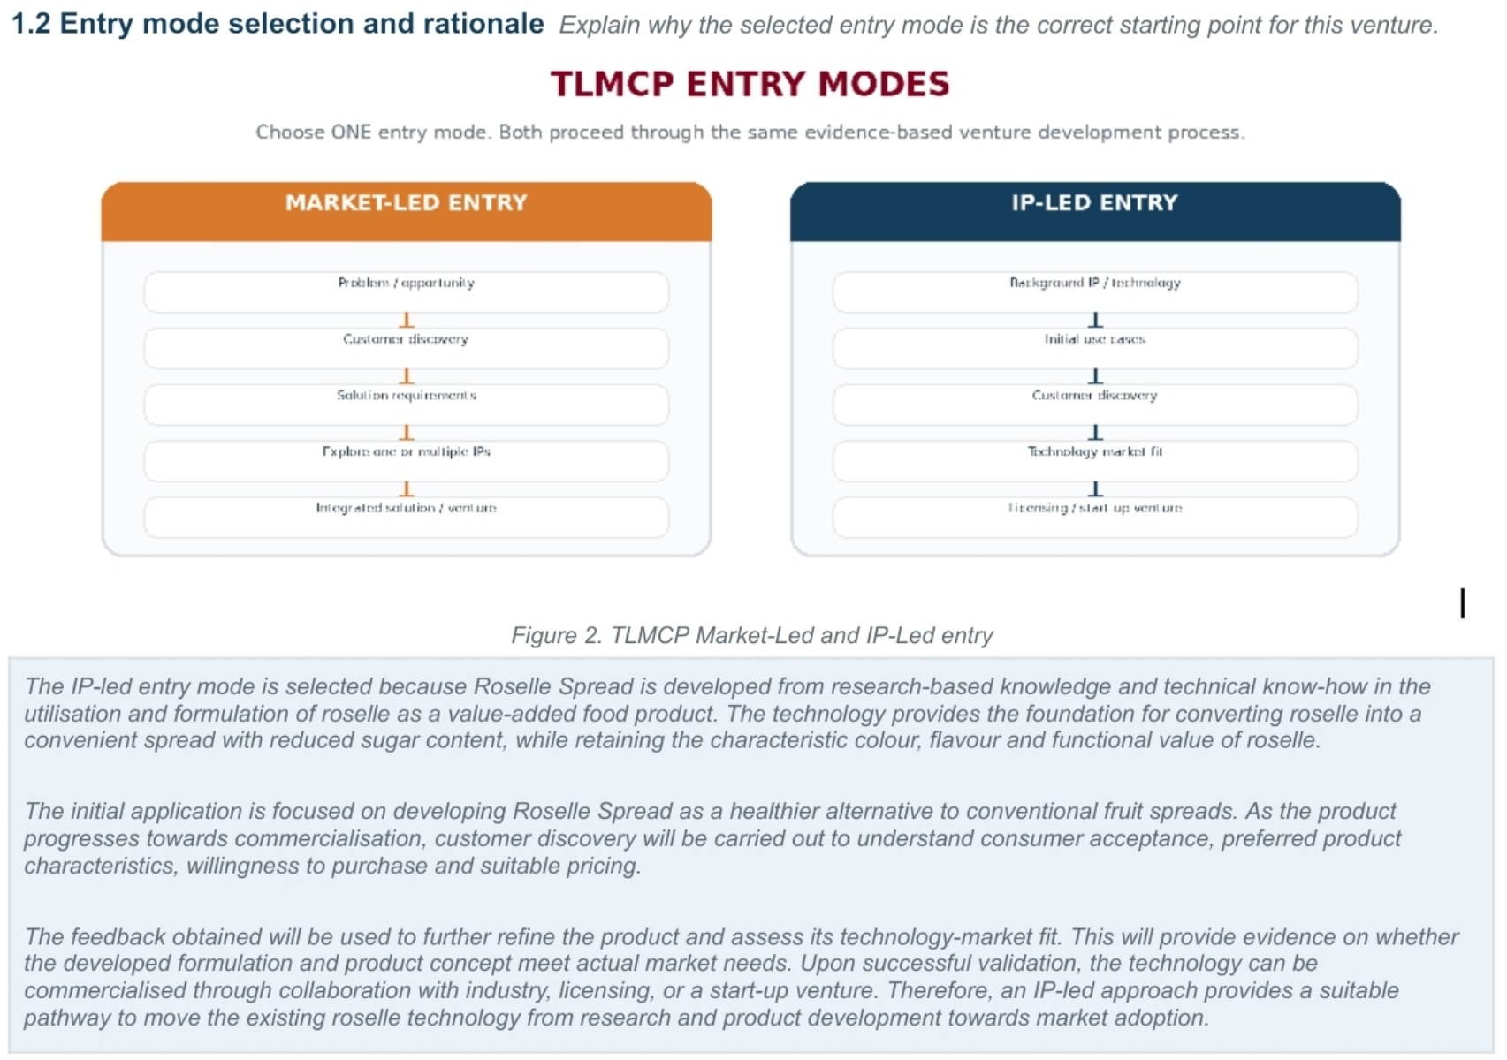
[ ] | Mandatory BMC, VPC and Business Testing training has been completed. | [Enter / attach evidence]
[ ] | Initial BMC, VPC and Business Testing Plan are attached. | [Enter / attach evidence]
[ ] | The proposal includes critical assumptions, evidence thresholds, milestones and a budget linked to validation. | [Enter / attach evidence]
[ ] | Market-Led: evidence of initial market/customer access and an IP/technology exploration approach are included. | [Enter / attach evidence]
[ ] | IP-Led: background IP, ownership/use rights, mentor commitment and initial use cases are included. | [Enter / attach evidence]

1 | VENTURE IDENTIFICATION | APPLICANT AND PROJECT DETAILS

1.1 Venture and application details
Proposed venture / project title | [Empowering Student Entrepreneurs Through Lab-to-Market Commercialisation of Functional Roselle Spread]
Selected entry mode | [ ] Market-Led Entry [ / ] IP-Led Entry
Venture Lead | -Nur Khairunnisa binti Mohd Hadi @ Mohd Haid  -Bachelor of Science in Biotechnology with Honours  -Faculty of science Department of Biosciences
Academic / Research Officer Mentor | -Ts. Dr. Siti Pauliena Mohd Bohari  -Faculty of science Department of Biosciences  -research entity
Proposed project period | 12 months
Grant requested | RM 15,000
Current venture status | [Validation]
Proposed commercialisation pathway | [Start-up]

1.2 Entry mode selection and rationale Explain why the selected entry mode is the correct starting point for this venture.
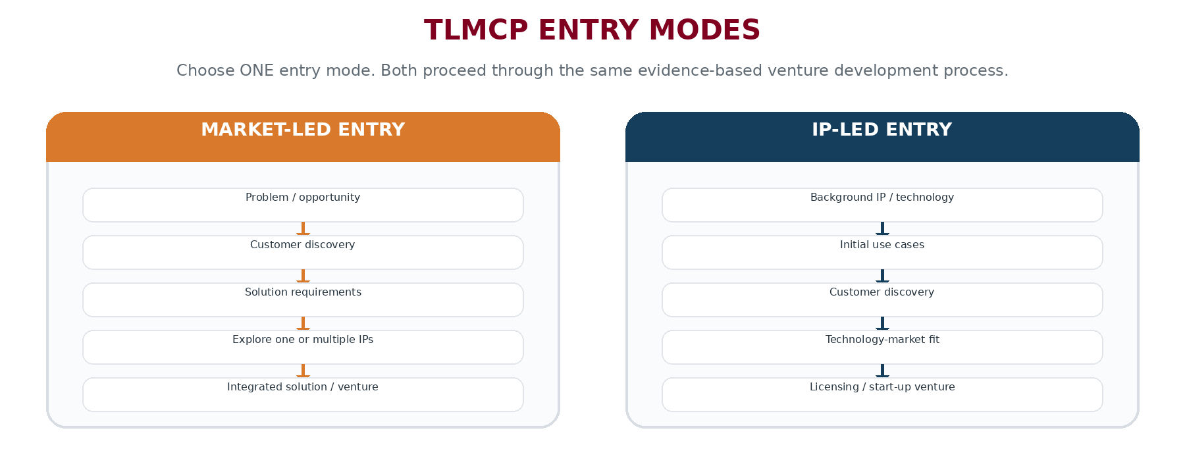
Figure 2. TLMCP Market-Led and IP-Led entry
The IP-led entry mode is selected because Roselle Spread is developed from research-based knowledge and technical know-how in the utilisation and formulation of roselle as a value-added food product. The technology provides the foundation for converting roselle into a convenient spread with reduced sugar content, while retaining the characteristic colour, flavour and functional value of roselle.

The initial application is focused on developing Roselle Spread as a healthier alternative to conventional fruit spreads. As the product progresses towards commercialisation, customer discovery will be carried out to understand consumer acceptance, preferred product characteristics, willingness to purchase and suitable pricing.

The feedback obtained will be used to further refine the product and assess its technology-market fit. This will provide evidence on whether the developed formulation and product concept meet actual market needs. Upon successful validation, the technology can be commercialised through collaboration with industry, licensing, or a start-up venture. Therefore, an IP-led approach provides a suitable pathway to move the existing roselle technology from research and product development towards market adoption.
1.3 Proposed venture outcome at the end of 12 months
Select | Target outcome | Proposed evidence / target date
[ ] | Company incorporation / SSM registration (Compulsory) | [Enter / attach evidence]
[ ] | Licensing, Deed of Assignment, term sheet or technology transfer agreement | [Enter / attach evidence]
[ ] | Industry pilot, proof-of-concept, paid engagement or early sales | [Enter / attach evidence]
[ ] | External funding / investment of at least RM50,000 | [Enter / attach evidence]
[ ] | LOI/LOC, first customer or commercial contract | [Enter / attach evidence]
[ ] | Investment readiness validated by the ICC panel | [Enter / attach evidence]

MINIMUM SUCCESS TARGET | A venture is considered successful when it achieves at least TWO of the programme success criteria before project completion.

2 | ELIGIBILITY, TEAM AND MENTOR | CONFIRM COMPLIANCE AND CAPABILITY

2.1 Eligibility confirmation
Selection | Requirement | Applicant confirmation / evidence
[ ] | The Venture Lead is a UTM undergraduate, postgraduate or eligible UTM alumnus. | 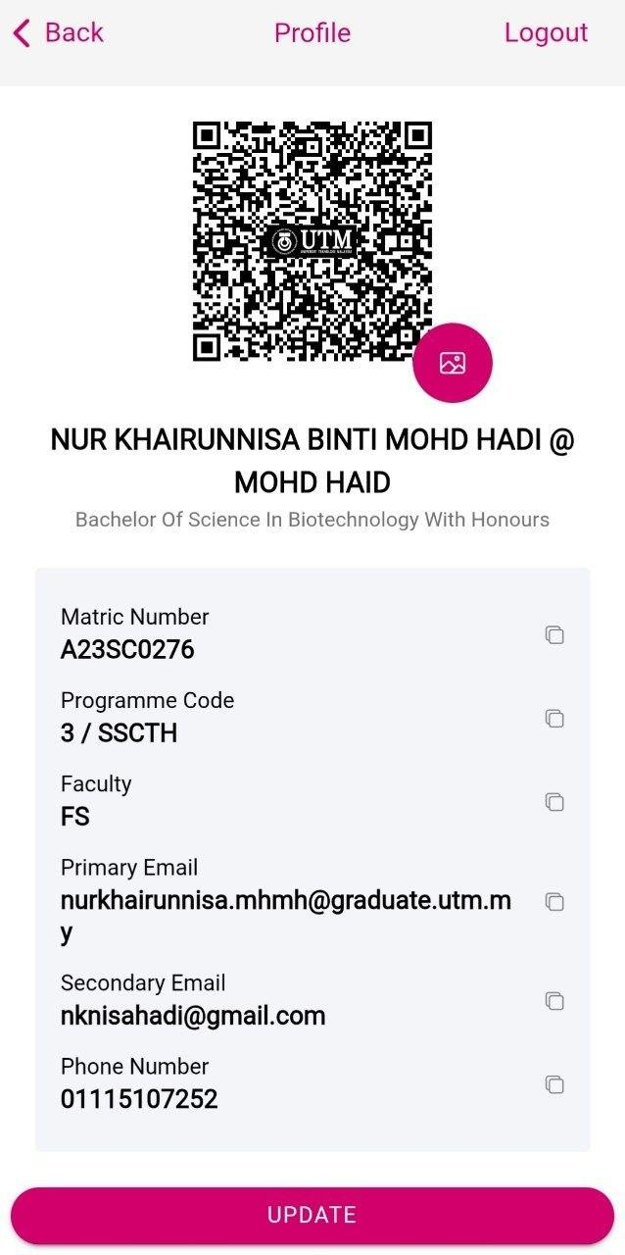
[ ] | A UTM alumnus is within 18 months of the Senate-approved graduation date. | -
[ ] | The undergraduate Venture Lead has a minimum CGPA of 3.00, or the postgraduate has Satisfactory (MM) status. | [Enter / attach evidence]
[ ] | Sponsored students have obtained permission from their sponsor. | [Enter / attach evidence]
[ ] | The team includes at least one Venture Lead, two UTM student/alumni members and one UTM academic/Research Officer mentor. | [Enter / attach evidence]
[ ] | The Venture Lead is leading only one TLMCP application at this time. | [Enter / attach evidence]
[ ] | The Venture Lead and team members have completed mandatory BMC, VPC and Business Testing training. | [Enter / attach evidence]
[ ] | The team is available for customer discovery, testing, monitoring, presentations and commercialisation activities. | [Enter / attach evidence]

2.2 Team composition and responsibilities
Name | Status / programme | Faculty / entity | Core expertise | Venture role | Commitment
Ts. Dr. Siti Pauliena Mohd Bohari | Senior Lecturer | Faculty of science Department of Biosciences | [Enter] | Academic / Research Officer Mentor | [Enter]
Nur Khairunnisa binti Mohd Hadi @ Mohd Haid | Bachelor of Science in Biotechnology with Honours | Faculty of science Department of Biosciences | Biotechnology | Venture Lead | [Enter]
Nur Shahirah Najwa binti Hasmadi | Bachelor of Science in Biotechnology with Honours | Faculty of science Department of Biosciences | Biotechnology | UTM Student Members | [Enter]
Auni Nadhrah binti Azhan | Bachelor of Science in Biology with Honours | Faculty of science Department of Biosciences | Biology | UTM Student Members (SYMBIOSIS) | [Enter]
2.3 Mentor commitment and contribution
[Describe the mentor’s technical, IP, industry and commercialisation role; maximum 250 words]
Ts. Dr. Siti Pauliena Mohd Bohari will serve as the Academic and Research Mentor, providing technical, research, intellectual property (IP), industry and commercialisation guidance throughout the development of the Roselle Spread venture. With her expertise and involvement in the research and development of the Roselle Spread, she will guide the team in maintaining product quality, scientific validity and consistency during scale-up and commercialisation.
Dr. Pauliena will advise the team on the appropriate utilisation and further development of the existing technology and background IP, ensuring that the venture remains aligned with its research foundation and IP potential. She will also support the team in identifying opportunities for product improvement, validation and differentiation to strengthen the product’s market position.
From an industry and commercialisation perspective, she will provide strategic guidance on product readiness, industry engagement, market validation and potential business partnerships. She will mentor the team in translating the existing Roselle Spread technology into a commercially viable venture and in developing a sustainable pathway from laboratory-based innovation to market adoption.
Her continued mentorship will strengthen the team’s technical credibility while supporting the transition of Roselle Spread from an existing research-based product into a scalable and commercially sustainable startup.

3 | VENTURE EXECUTIVE SUMMARY | OPPORTUNITY, EVIDENCE AND INTENDED OUTCOME

WRITE FOR DECISION-MAKERS | Summarise the market problem or IP opportunity, customer, proposed value, current evidence, major uncertainty, testing plan and intended venture outcome.

3.1 Executive summary
[Maximum 400 words]
Roselle Spread is an existing functional food product developed from roselle (Hibiscus sabdariffa L.), offering an opportunity to translate existing research and intellectual property (IP) into a commercially viable venture. The product addresses the growing demand for healthier food alternatives, particularly spreads with lower sugar content compared with conventional sweet spreads. This opportunity is especially relevant in Malaysia, which has a high and increasing prevalence of diabetes, creating a strong need for more health-conscious food choices.
The primary customers are health-conscious consumers, individuals seeking lower-sugar food products, families and consumers who are concerned about excessive sugar intake, including consumers with diabetes who require greater awareness of their dietary sugar consumption. Roselle Spread offers a convenient and familiar food format while incorporating roselle, a locally available botanical ingredient known for its antioxidant compounds. Its lower-sugar positioning and potential antioxidant benefits provide differentiation from conventional high-sugar spreads and strengthen its potential as a functional food product.
The product already demonstrates promising commercial potential. Roselle Spread has gained market exposure through placement and sales at locations including PETRONAS UTM, UTM Mart and Student Mall, while online sales through TikTok have also received encouraging customer response. These existing sales channels provide preliminary evidence of market acceptance and demonstrate that the product has progressed beyond the concept stage.
However, the major uncertainty is whether the existing product can achieve stronger product-market fit, repeat purchase and scalable commercial growth while maintaining consistent quality, pricing and production capacity. The proposed RM15,000 funding will therefore be used to validate key commercial assumptions through customer feedback, product and packaging refinement, pricing and purchase-intention testing, and assessment of production and distribution scalability.
The intended outcome is to establish a stronger market-validated proposition and a clear commercialisation pathway for Roselle Spread. Through the IP-Led Entry approach, the venture aims to transform the existing research, product and IP foundation into a sustainable student/alumni-led startup with the potential for wider market adoption and future industry collaboration.

3.2 Twelve-month venture objective
[State measurable objectives that integrates validation, technology/IP fit, business viability and venture formation.]

Within 12 months, the Roselle Spread venture aims to:
- Validate market and product–market fit by conducting structured customer discovery and market testing, obtaining at least 30–50 cumulative consumer responses and 10 cumulative quality customer/industry engagements, and validating the target customer segment, willingness-to-pay, preferred packaging, pricing and market positioning.

- Validate technology/IP-market fit by leveraging the existing Roselle Spread research, technology and IP foundation to refine the product, packaging and value proposition based on validated market feedback, while ensuring alignment between the existing IP and the identified commercial application.

- Demonstrate business viability through pilot market entry in at least 3 selected outlets/channels, engagement with at least 2 potential business partners, and collection of actual sales, customer-response and channel-performance data to validate pricing, costing, margins and the most viable market-entry channels.

- Establish venture and commercialisation readiness by finalising the Business Model Canvas (BMC), Value Proposition Canvas (VPC), go-to-market strategy, pricing and margin structure, and a 90-day post-grant commercialisation plan, positioning Roselle Spread as a structured student/alumni-led venture ready for continued market expansion and industry collaboration.

3.3 Key decision sought at project completion
[What decision should the evidence enable: incorporate, license, pilot, sell, raise funding, continue validation, pivot or stop?]

4 | ENTRY MODE FOUNDATION | COMPLETE 4A OR 4B ONLY

CONDITIONAL COMPLETION | Complete the section for the selected entry mode. For the other section, write "NR - Not Relevant" and explain briefly.

4A. MARKET-LED ENTRY Complete only when the venture starts with a customer problem or market opportunity.
4A.1 Problem / opportunity statement
[Define the target customer, problem/opportunity, context, frequency, severity and measurable consequence; maximum 300 words]

4A.2 Initial customer and market evidence
Evidence source | Date | What was observed / learned | What it supports | Attachment reference
[Enter] | [Enter] | [Enter] | [Enter] | [Enter]
[Enter] | [Enter] | [Enter] | [Enter] | [Enter]
[Enter] | [Enter] | [Enter] | [Enter] | [Enter]
4A.3 Initial market/customer access
[Identify accessible customers, industries or stakeholders, access method, current relationships and access risks; maximum 250 words]

4A.4 Solution requirements derived from market evidence
Requirement | Evidence basis | Priority | How it will be tested
[Enter] | [Enter] | [Enter] | [Enter]
[Enter] | [Enter] | [Enter] | [Enter]
[Enter] | [Enter] | [Enter] | [Enter]
4A.5 IP / technology exploration strategy
[Explain how the team will explore UTM IP portfolios, patents, technologies, researchers and partners; include criteria for selecting one or multiple IPs; maximum 300 words]

4B. IP-LED ENTRY Complete only when the venture starts with existing technology or background IP.
4B.1 Background IP / technology summary
IP / technology title | [Enter]
Inventor / owner | [Enter]
Registration / disclosure reference | [Enter / attach]
Ownership or authorised use status | [Enter / attach evidence]
Current TRL / readiness | TRL9 - Technology readiness
Core function and advantage | [Enter]
Known limitations | [Enter]
Mentor commitment to licensing / transfer consideration | [Enter / attach letter or confirmation]
4B.2 Initial use cases and customer segments
Use case | Target customer | Problem addressed | Expected value | Current evidence | Priority
Healthier breakfast and daily spread | Health-conscious consumers | Conventional spreads may contain high levels of added/refined sugar | Lower-sugar alternative with the distinctive taste and colour of roselle |  | High
Functional / Local food product | Consumers interested in functional and locally sourced food | Limited convenient food products that add value to roselle as a local crop | Convenient way to consume roselle while creating higher value from a local agricultural resource |  | High
Retail / gift / specialty food market | Retail customers and specialty food outlets | Limited differentiated local spread products with a strong roselle identity | Differentiated Malaysian product with potential for retail expansion and repeat purchase | 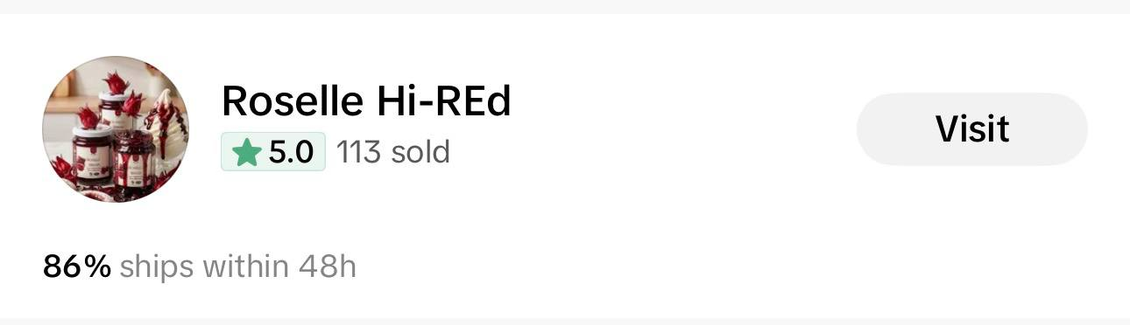 | Medium
4B.3 Technology understanding and adaptation requirements
[Describe functionality, operating conditions, integration, adaptation, technical testing, regulatory constraints and market-fit uncertainties; maximum 350 words]
Roselle Spread is a research-based food formulation developed to utilise roselle as a value-added spread product with reduced sugar content. The current product demonstrates the feasibility of converting roselle into a convenient food application with acceptable spreadability, colour, flavour and consumer use. The existing formulation provides a starting point for further commercialisation and scale-up.

For market entry, several aspects still require further evaluation and optimisation. These include product consistency between production batches, physicochemical and microbiological stability, shelf life, and the suitability of the current packaging for storage and distribution. Scale-up trials are also required to ensure that the product characteristics can be maintained when moving from small-scale preparation to larger production.

Food safety and regulatory requirements for a commercial food product will also need to be addressed, including appropriate labelling, nutritional information and other applicable requirements. In parallel, customer discovery will be used to assess taste preference, texture, packaging, serving size and acceptable price.

The main market-fit uncertainty is whether the current product attributes and positioning are sufficiently attractive for repeat purchase beyond existing users. Therefore, the next stage will focus on technical validation, product refinement, customer feedback and commercial testing to establish a consistent, safe and market-ready Roselle Spread.

4B.4 Licensing / technology transfer readiness
[Describe ownership, rights, mentor/inventor willingness, potential licensing model, foreground IP and key constraints; maximum 250 words]

5 | CUSTOMER, MARKET AND COMPETITIVE EVIDENCE | DESIRABILITY AND MARKET ACCESS

5.1 Customer profile and roles
User | Buyer / payer | Decision-maker | Beneficiary / influencer
[Enter] | [Enter] | [Enter] | [Enter]
[Enter] | [Enter] | [Enter] | [Enter]
5.2 Customer problem and value statement
[Use: "[Target customer] experiences [specific problem] when [context], resulting in [measurable consequence]. The proposed venture creates value by [outcome]."]

5.3 Existing alternatives and current behaviour
Current alternative | Why customers use it | Weakness / unmet need | Switching barrier | Evidence source
[Enter] | [Enter] | [Enter] | [Enter] | [Enter]
[Enter] | [Enter] | [Enter] | [Enter] | [Enter]
5.4 Customer and industry access plan
Target group / organisation | Access route | Contact status | Expected evidence | Responsible person
[Enter] | [Enter] | [Enter] | [Enter] | [Enter]
[Enter] | [Enter] | [Enter] | [Enter] | [Enter]
[Enter] | [Enter] | [Enter] | [Enter] | [Enter]

6 | VPC AND BMC | INITIAL VENTURE LOGIC - EXPECTED TO EVOLVE
6.1 Value Proposition Canvas (VPC) summary

Please attach your VPC

6.2 Business Model Canvas (BMC) summary

Please attach your BMC

7 | CRITICAL ASSUMPTIONS | PRIORITISE UNCERTAINTY AND CONSEQUENCE

PRIORITISE FIRST | Select assumptions that are both highly uncertain and highly consequential. Do not list routine activities as assumptions.

7.1 Critical assumption register
ID | Critical assumption | DFV dimension | Existing evidence | Confidence | Consequence if wrong
A1 | [Enter] | [Enter] | [Enter] | [Enter] | [Enter]
A2 | [Enter] | [Enter] | [Enter] | [Enter] | [Enter] c
A3 | [Enter] | [Enter] | [Enter] | [Enter] | [Enter]
7.2 Top three assumptions to test first
Priority | Assumption ID | Why test first | Decision affected
1 | [Enter] | [Enter] | [Enter]
2 | [Enter] | [Enter] | [Enter]
3 | [Enter] | [Enter] | [Enter]

8 | BUSINESS TESTING AND EVIDENCE PLAN |  | ASSUMPTION - TEST - EVIDENCE - THRESHOLD - DECISION

8.1 Test design
Test ID | Gate | Assumption ID | Test / experiment | Target / source | Prototype / artefact
T1 | [Enter] | [Enter] | [Enter] | [Enter] | [Enter]
T2 | [Enter] | [Enter] | [Enter] | [Enter] | [Enter]
T3 | [Enter] | [Enter] | [Enter] | [Enter] | [Enter]
T4 | [Enter] | [Enter] | [Enter] | [Enter] | [Enter]
8.2 Evidence, threshold and decision
Test ID | Evidence to collect | Success threshold | Decision if met | Decision if not met
T1 | [Enter] | [Enter] | [Enter] | [Enter]
T2 | [Enter] | [Enter] | [Enter] | [Enter]
T3 | [Enter] | [Enter] | [Enter] | [Enter]
T4 | [Enter] | [Enter] | [Enter] | [Enter]
8.3 Minimum customer / stakeholder engagement plan
MANDATORY MINIMUM | Plan for at least 10 quality interviews or stakeholder engagements. Quality is determined by relevance, evidence captured and learning generated - not only by the number completed.

Engagement group | Minimum target | Purpose / assumption | Evidence captured | Timing
[Enter] | [Enter] | [Enter] | [Enter] | [Enter]
[Enter] | [Enter] | [Enter] | [Enter] | [Enter]
[Enter] | [Enter] | [Enter] | [Enter] | [Enter]
[Enter] | [Enter] | [Enter] | [Enter] | [Enter]
8.4 Evidence log and auditability
[Describe how raw evidence, consent, interview notes, test artefacts, dates, respondent profiles, results and decisions will be stored and linked to the evidence log; maximum 250 words]

9 | TECHNOLOGY, IP AND SOLUTION STRATEGY | FIT, ADAPTATION AND COLLABORATION

9.1 Technology / IP selection and fit
Candidate technology / IP | Owner / partner | Selection criteria | Current evidence of fit | Next validation action
[Enter / NR] | [Enter / NR] | [Enter / NR] | [Enter / NR] | [Enter / NR]
[Enter / NR] | [Enter / NR] | [Enter / NR] | [Enter / NR] | [Enter / NR]
[Enter / NR] | [Enter / NR] | [Enter / NR] | [Enter / NR] | [Enter / NR]
[Enter / NR] | [Enter / NR] | [Enter / NR] | [Enter / NR] | [Enter / NR]
9.2 Technology-market fit / integrated solution fit questions
Fit question | DFV dimension | Evidence needed | Threshold | Decision / adaptation
[Enter] | [Enter] | [Enter] | [Enter] | [Enter]
[Enter] | [Enter] | [Enter] | [Enter] | [Enter]
[Enter] | [Enter] | [Enter] | [Enter] | [Enter]
[Enter] | [Enter] | [Enter] | [Enter] | [Enter]
[Enter] | [Enter] | [Enter] | [Enter] | [Enter]
[Enter] | [Enter] | [Enter] | [Enter] | [Enter]
9.3 Multi-IP / integrated solution collaboration plan
[Where relevant, explain the need for multiple IPs or owners, the integration logic, commitment required, roles, governance and fit testing. Otherwise state NR with reason; maximum 300 words]

9.4 IP, licensing, transfer and foreground IP plan
[Explain background IP status, rights/permissions, licensing or transfer pathway, foreground IP potential, confidentiality and agreement requirements; maximum 300 words]

10 | BUSINESS PROTOTYPE AND EXPERIMENT ROADMAP | BUILD ONLY WHAT IS NECESSARY TO LEARN

PROTOTYPE PRINCIPLE | The prototype is a test instrument. It should be the simplest credible artefact that enables the team to collect decision-relevant evidence.

10.1 Prototype / artefact plan
Prototype / artefact | Assumption tested | Target participant | Interaction / test | Evidence expected | Gate
Prototype 1: Roselle Spread + basic packaging | Consumers will find the taste, texture and sweetness acceptable as a spread. | 20–30 potential consumers | Product tasting + short survey | ≥70% positive acceptance; key feedback on taste, texture and sweetness. | Proceed to packaging refinement if the acceptance target is met.
Prototype 2: Improved Roselle Spread + packaging concept | Consumers are willing to purchase the product at the proposed price and packaging is attractive. | Health-conscious consumers, UTM community, potential buyers | Product testing + packaging/price survey | Purchase intention, preferred packaging, acceptable price range. | Proceed to pilot sales if purchase intention and price acceptance are satisfactory.
Prototype 3: Pilot-market product | The product can generate actual customer demand in a real market setting. | Potential customers + selected retail/market channels | Small-scale pilot sales + customer feedback | Number of units sold, repeat purchase interest, customer feedback. | Proceed to commercialization/industry engagement if sales and feedback meet targets.
10.2 Why this is the simplest appropriate prototype
[Explain why the proposed artefact is sufficient for learning and how the team will avoid premature technology development; maximum 200 words]

The proposed prototype is a small-batch Roselle Spread with basic packaging and labelling. It is sufficient for early validation because it allows the team to test the most important business assumptions before investing in further development. Through product tasting and customer feedback, we can learn whether consumers accept the taste, texture, sweetness, appearance and overall concept of the product.

At this stage, the aim is not to develop a final commercial product or optimize every technical aspect. The team will focus only on the features that are necessary for customers to experience and evaluate the product. Feedback from the target users will guide the next formulation, packaging and pricing decisions.

To avoid premature technology development, we will use small production batches, existing formulation knowledge and simple packaging during the initial testing. Further technical optimisation, scale-up and packaging investment will only be considered after sufficient evidence of customer acceptance and market interest is obtained. This approach allows the team to learn quickly, minimise cost and reduce the risk of developing a product that does not meet market needs.

10.3 Minimum technical tests linked to market hypotheses
Technical test | Market / customer hypothesis | Performance threshold | Evidence | Decision
[Enter / NR] | [Enter / NR] | [Enter / NR] | [Enter / NR] | [Enter / NR]
[Enter / NR] | [Enter / NR] | [Enter / NR] | [Enter / NR] | [Enter / NR]
[Enter / NR] | [Enter / NR] | [Enter / NR] | [Enter / NR] | [Enter / NR]
[Enter / NR] | [Enter / NR] | [Enter / NR] | [Enter / NR] | [Enter / NR]

11 | NINETY-DAY PLAN AND TWELVE-MONTH MILESTONES | SEQUENCE LEARNING AND VENTURE ACTION

11.1 Initial 90-day action plan
Period | Activity | Gate / assumption | Evidence expected | Decision | Responsible person
Weeks 1-2 | Conduct customer discovery through interviews & stakeholder engagement | Target customers have a clear need for a lower-sugar and functional food spread. | ≥15–20 customer interviews, stakeholder feedback and documented insights. | Proceed with the identified target customer segment and refine the value proposition if needed. | Venture Lead / Marketing Lead
Weeks 3-4 | Conduct product validation and taste testing of Hi-REd Roselle Spread. | Customers accept the product's taste, texture, packaging and overall concept. | Product testing results, customer ratings and qualitative feedback. | Improve product formulation or packaging based on customer feedback, if required. | Technical / Product Lead
Month 2 | Conduct small-scale market testing and initial sales. | Customers are willing to purchase the product at the proposed selling price. | Sales records, number of units sold, customer feedback and purchase intent. | Proceed with market expansion if demand and pricing are validated; otherwise revise pricing or positioning. | Marketing & Sales Lead
Month 3 | [Develop commercialisation strategy and strengthen retail/industry partnerships. | The product demonstrates sufficient market demand and a viable route to market. | Sales performance, production cost analysis, retailer/distributor interest and partnership discussions. | Proceed to scale-up and wider market entry, or refine the business model based on evidence. | Venture Lead / Business Development Lead
11.2 Twelve-month milestone plan
Period | Gate / activity | Milestone / output | Evidence | Venture decision | Responsible person
Months 1-3 | Milestone 1: Customer Discovery  Define target customer hypotheses; conduct customer interviews/surveys; Roselle Spread sampling and feedback; test taste, texture, packaging and price assumptions; initial competitor benchmarking. | Initial Customer & Market Validation  Initial customer profile, preliminary value proposition and business assumptions established. | ≥15–20 consumer responses; ≥5 quality customer/industry engagements; initial BMC, VPC and Business Testing Plan; customer feedback and competitor benchmarking data. | Gate 1: Proceed to expanded market validation if target customer needs and product assumptions show sufficient potential; otherwise refine customer segment/value proposition. | Venture Lead & Team; Academic/Research Mentor
Months 4-6 | Milestone 2: Product–  Market Validation  Expand market validation; validate willingness-to-pay; test preferred packaging, pricing and positioning; analyse feedback; refine BMC, VPC and channel hypotheses. | Validated Product–Market Proposition  Target segment, price range, packaging and positioning validated. | ≥30–50 cumulative consumer responses; ≥10 cumulative quality engagements; validated target segment and price range; preferred positioning/packaging; market validation report and evidence log. | Gate 2: Proceed to pilot market entry if market demand, willingness-to-pay and product positioning are sufficiently validated; otherwise refine product/market assumptions. | Venture Lead & Team; Academic/Research Mentor
Months 7-9 | Milestone 3: Pilot Market Entry  Prepare pilot commercial batches; apply validated packaging and pricing; conduct pilot sales; approach suitable retailers/cafés; track sales, feedback and repeat-purchase signals. | Pilot Market Traction —  Roselle Spread tested in real commercial channels and initial sales performance established. | Pilot in ≥3 selected outlets/channels; ≥2 potential business partners engaged; actual sales and customer-response data; early channel-performance evidence. | Gate 3: Select the most promising market channel(s) and proceed to commercialisation readiness if pilot results demonstrate sufficient traction; otherwise refine pricing, positioning or channel strategy. | Venture Lead & Team; Academic/Research Mentor
Months 10-12 | Milestone 4: Commercialisation Readiness  Analyse sales/channel performance; validate costing, margin and pricing; select best-performing channels; finalise business model and go-to-market strategy; prepare post-grant commercialisation pathway. | Commercialisation-Ready Venture —  Final business model, pricing structure and market-entry strategy established. | Final cost, pricing and margin structure; documented market traction; final BMC/venture model; 90-day commercialisation plan; Demo Day/Commercialisation Review readiness. | Final Gate: Proceed to venture formation, continued sales, broader commercialisation and further funding/industry partnerships if validation targets are achieved; otherwise continue targeted validation/refinement. | Venture Lead & Team; Academic/Research Mentor
11.3 Dependencies and learning sequence
[Explain what must be learned first, how later activities depend on earlier evidence and where the team will stop or pivot if thresholds are not met; maximum 250 words]
The venture will follow a sequential evidence-based learning process, where each stage depends on the evidence generated from the previous stage. First, customer discovery will establish the target customer profile, key needs and initial assumptions regarding taste, texture, packaging and price. Only if sufficient customer interest is identified will the team proceed to broader product–market validation.
The second stage will test willingness-to-pay, preferred packaging, pricing and market positioning. Evidence from this stage will determine whether Roselle Spread demonstrates sufficient product–market fit to justify pilot market entry. If customer acceptance or willingness-to-pay is below the defined threshold, the team will refine the product, pricing or positioning and repeat targeted validation before proceeding.
Once the key market assumptions are sufficiently validated, the team will conduct pilot sales through at least three selected outlets or channels. Sales performance, customer feedback, repeat-purchase signals and channel response will determine which market channels should be prioritised.
The final stage will assess costing, margins, pricing and overall business viability, leading to a final business model and go-to-market strategy. If the evidence demonstrates sufficient traction and commercial viability, the venture will proceed towards commercialisation, venture formation and further funding. If critical assumptions remain unresolved, the team will continue targeted validation or pivot the product, positioning or channel strategy rather than proceeding directly to scale-up.

12 | BUDGET AND FUNDING JUSTIFICATION | MAXIMUM RM15,000; LINKED TO VALIDATION AND VENTURE DEVELOPMENT

BUDGET RULE | Funds must support customer discovery, business testing, IP/patent mapping, market analysis, prototypes, minimum technical tests, venture documentation, pilots, market access or investment readiness. Technology development without a clear market hypothesis is not eligible.

12.1 Detailed budget
Budget item | Amount (RM) | Stage gate | Assumption / test supported | Evidence / output | Justification
Travel & Subsistence | 6000 | Gate 1–3: Customer Discovery, Product–Market Validation & Pilot Market Entry | Whether target customers accept Roselle Spread and whether there is genuine market demand through customer, retailer and industry engagement. | ≥30–50 cumulative consumer responses; ≥10 quality customer/industry engagements; customer feedback records; retailer/industry engagement records; pilot sales and channel-performance data. | Supports direct customer discovery, market validation, retailer engagement and local pilot market testing. Face-to-face engagement enables the team to obtain meaningful feedback and validate market assumptions in real market settings.
Rentals, Transportation & Utilities | 1000 | Gate 1–3: Customer Discovery, Product–Market Validation & Pilot Market Entry | Whether selected market-testing locations and channels are suitable for reaching target customers and generating meaningful market feedback. | Market-testing activities conducted; booth/space records; customer engagement data; channel feedback. | Supports temporary booth/space rental, transportation and utilities required for selected market-testing activities and direct customer engagement.
Materials & Supplies | 1000 | Gate 2–3: Product–Market Validation & Pilot Market Entry | Whether customers accept the validated product format, packaging and presentation sufficiently to support pilot sales. | Pilot batches; product samples; customer taste/feedback records; validated packaging and labels; pilot sales data. | Supports pilot batches, ingredients, food-grade packaging, labels, sampling and validation materials required to test product acceptance and commercial presentation.
Professional Services | 2000 | Gate 2–4: Product–Market Validation & Commercialisation Readiness | Whether improved packaging, branding and supporting materials strengthen customer perception and commercial positioning. | Refined packaging and branding; printed materials; validation materials; improved product presentation; commercialisation-ready materials. | Provides specialist support for packaging, branding, printing and relevant services needed to strengthen the existing product/IP into a more market-ready commercial offering.
Equipment & Accessories | 5000 | Gate 3–4: Pilot Market Entry & Commercialisation Readiness | Whether the venture can consistently prepare pilot commercial batches and support production requirements at a level suitable for market testing and future scale-up. | Pilot production capability; prepared commercial batches; production records; improved process consistency; operational readiness evidence. | Supports small-scale equipment and accessories specifically required for pilot business-prototype preparation, enabling consistent production and testing before wider commercialisation.
TOTAL REQUEST | RM [Enter] |  | Maximum RM15,000

12.2 Budget narrative and value for money
[Explain why the selected methods are proportionate, how costs directly support evidence generation and how the team avoids premature development; maximum 300 words]

The proposed RM15,000 budget is proportionate to the current maturity of Roselle Spread, which is an existing research-based product with initial market exposure. Rather than investing prematurely in large-scale production, the funding will be focused on generating the evidence required to reduce key market and commercialisation uncertainties.
The selected methods directly support the venture’s four stage gates. Travel and subsistence, together with rentals, transportation and utilities, will enable customer discovery, industry engagement, market testing and pilot activities, generating customer responses, industry engagement records and channel-performance data. Materials and supplies will support product sampling and pilot commercial batches, allowing the team to test product acceptance, packaging and pricing assumptions. Professional services will support market-ready packaging, branding and relevant commercialisation materials, while equipment and accessories will enable consistent small-scale pilot production and provide evidence of production readiness.
Value for money will be achieved by linking each expenditure to a measurable validation output, including 30–50 cumulative consumer responses, at least 10 quality customer/industry engagements, pilot testing across at least three selected outlets or channels, engagement with at least two potential business partners, and validated costing, pricing and margin structures.
The team will avoid premature development by following a staged, evidence-based approach: customer discovery first, followed by product–market validation, pilot sales and finally commercialisation readiness. Larger-scale production and expansion will only be pursued if the preceding evidence meets the defined thresholds. If critical assumptions are not validated, the team will refine or pivot the product, pricing or market-entry strategy before committing further resources.

12.3 Stage-gated funding release readiness
[State how the team will manage staged fund release, evidence verification, financial records and adjustments if a gate is not achieved; maximum 200 words]

The team will manage the RM15,000 funding through a stage-gated and evidence-based approach, with expenditure aligned to the approved budget and project milestones. Each stage will be reviewed based on predefined outputs and evidence before proceeding to subsequent activities.
Evidence such as customer responses, engagement records, pilot sales data, invoices, receipts, market validation reports, costing analysis and updated BMC/VPC will be systematically documented and verified by the Venture Lead together with the Academic/Research Mentor.
All financial transactions will be recorded and supported by appropriate receipts or invoices, with expenditure monitored against the approved budget to ensure transparency, accountability and appropriate use of funds.
If a stage gate is not achieved, the team will pause or adjust subsequent expenditure and review the underlying assumptions. Where appropriate, funds will be redirected within the approved project scope towards targeted re-validation, product refinement, pricing adjustment or channel testing. Progression to the next stage will only occur when sufficient evidence is obtained. This ensures that funding is deployed based on validated learning and that financial resources are protected from premature scale-up.

13 | MANDATORY OUTPUTS AND VENTURE SUCCESS | COMMIT TO AUDITABLE RESULTS

13.1 Mandatory programme outputs
Commit | Mandatory output | Proposed evidence / completion date
[ ] | Completed and updated BMC, VPC, Business Testing Record and evidence log. | [Enter / attach evidence]
[ ] | At least 10 quality customer/stakeholder interviews or engagements. | [Enter / attach evidence]
[ ] | Evidence-based assessment of Desirability, Feasibility and Viability. | [Enter / attach evidence]
[ ] | Technology-market fit or integrated solution fit report. | [Enter / attach evidence]
[ ] | A 90-day plan and recommended commercialisation pathway. | [Enter / attach evidence]
[ ] | Presentation at TLMCP Demo Day / Commercialisation Review. | [Enter / attach evidence]

13.2 Selected venture success targets - choose at least TWO
Select | Success criterion | Target evidence / target date
[ ] | Company incorporation / SSM registration | [Enter / attach evidence]
[ ] | Licensing, Deed of Assignment, term sheet or technology transfer agreement | [Enter / attach evidence]
[ ] | Industry pilot, proof-of-concept, paid engagement or early sales | [Enter / attach evidence]
[ ] | External funding / investment of at least RM50,000 | [Enter / attach evidence]
[ ] | LOI/LOC, first customer or commercial contract | [Enter / attach evidence]
[ ] | Investment readiness validated by the ICC panel | [Enter / attach evidence]

13.3 Current commercialisation pathway and rationale
[Explain the current preferred pathway and the evidence that would confirm or change it; maximum 250 words]

13.4 Intended final venture classification
Select | Classification | Applicant interpretation / evidence target
[ ] | Prospective Venture | [Enter]
[ ] | Validated Venture | [Enter]
[ ] | Established Venture | [Enter]

14 | RISKS, GOVERNANCE, ETHICS AND IP PROTECTION | PROTECT EVIDENCE INTEGRITY AND VENTURE CONTINUITY

14.1 Risk register
Risk | Likelihood | Impact | Mitigation / prevention | Trigger / indicator | Owner
Customer / market access | [Enter] | [Enter] | [Enter] | [Enter] | [Enter]
Technology / integration | [Enter] | [Enter] | [Enter] | [Enter] | [Enter]
IP / licensing | [Enter] | [Enter] | [Enter] | [Enter] | [Enter]
Team continuity | [Enter] | [Enter] | [Enter] | [Enter] | [Enter]
Financial / procurement | [Enter] | [Enter] | [Enter] | [Enter] | [Enter]
Data / confidentiality | [Enter] | [Enter] | [Enter] | [Enter] | [Enter]
Regulatory / ethics | [Enter] | [Enter] | [Enter] | [Enter] | [Enter]
Partner commitment | [Enter] | [Enter] | [Enter] | [Enter] | [Enter]
14.2 Confidentiality and IP disclosure during customer discovery
[Explain what may be disclosed, what must remain confidential, whether NDA/consent is needed and how potentially protectable foreground IP will be managed; maximum 250 words]

14.3 Data, privacy and ethical considerations
[Describe participant consent, personal data handling, storage, access control and any ethics or regulatory approval required; maximum 200 words]

14.4 Governance, conflicts and decision authority
[Describe decision rights among Venture Lead, team, mentor, IP owner and partners; identify conflicts of interest and escalation arrangements; maximum 250 words]

15 | ATTACHMENTS AND DECLARATION | SUBMISSION COMPLETENESS AND ACCOUNTABILITY

15.1 Common mandatory attachments
Attach | Common attachment | File name / reference
[ ] | Evidence of completion of BMC, VPC and Business Testing training. | [Enter / attach evidence]
[ ] | Initial Business Model Canvas (BMC). | [Enter / attach evidence]
[ ] | Initial Value Proposition Canvas (VPC). | [Enter / attach evidence]
[ ] | Initial Business Testing Plan. | [Enter / attach evidence]
[ ] | Venture Lead profile / CV. | [Enter / attach evidence]
[ ] | Team member profiles. | [Enter / attach evidence]
[ ] | Mentor profile and commitment confirmation. | [Enter / attach evidence]
[ ] | Detailed milestone plan and budget. | [Enter / attach evidence]
[ ] | Supporting market, customer, technical or partnership evidence. | [Enter / attach evidence]
[ ] | Sponsor permission, where applicable. | [Enter / attach evidence]

15.2 Market-Led Entry attachments
Attach / NR | Market-Led attachment | File name / reference
[ ] | Problem / opportunity evidence. | [Enter / attach evidence]
[ ] | Evidence of initial customer, industry or stakeholder access. | [Enter / attach evidence]
[ ] | Preliminary interview, observation or secondary evidence, where available. | [Enter / attach evidence]
[ ] | Proposed IP / technology exploration and selection approach. | [Enter / attach evidence]

15.3 IP-Led Entry attachments
Attach / NR | IP-Led attachment | File name / reference
[ ] | Background IP / technology summary. | [Enter / attach evidence]
[ ] | IP registration, disclosure or ownership/use-right information. | [Enter / attach evidence]
[ ] | Mentor / inventor commitment to consider licensing or transfer. | [Enter / attach evidence]
[ ] | Initial use-case and target customer analysis. | [Enter / attach evidence]
[ ] | Available technical test or readiness evidence. | [Enter / attach evidence]

15.4 Applicant declaration
DECLARATION | I/We declare that the information provided in this proposal is accurate to the best of our knowledge; the team meets the applicable eligibility requirements; the proposed expenditure is directly linked to validation and venture development; customer discovery and evidence activities will be conducted ethically; and the team agrees to comply with ICC/RMC monitoring, financial, IP and reporting requirements.

Venture Lead name | Nur Khairunnisa binti Mohd Hadi @ Mohd Haid | Signature / date |   21/8/2026
Academic / Research Officer Mentor | Ts. Dr Siti Pauliena binti Mohd Bohari | Signature / date | 21/8/2026
Team representative | Nur Shahirah Najwa binti Hasmadi | Signature / date |   21/8/2026
IP owner / inventor, where applicable | [Enter / NR] | Signature / date | [Enter / NR]
Official contact | [Enter] | Email / telephone | [Enter]
END OF TLMCP VENTURE APPLICATION PROPOSAL TEMPLATE
Official criteria and instructions issued by ICC/RMC prevail in the event of any inconsistency.

